**NAME: Meet Raut**

**DIV: S2-1**

**ROLL NO: 2201084**

* **EXPERIMENT – 13:**

* ***AIM:*** **To study and implement programs to demonstrate Data Series and Data Frames using Pandas.**

* ***THEORY:***

Pandas DataFrame is a widely used data structure which works with a two-dimensional array with labeled axes (rows and columns). DataFrame is defined as a standard way to store data that has two different indexes, i.e., **row index** and **column index**. It consists of the following properties:

* The columns can be heterogeneous types like int, bool, and so on.
* It can be seen as a dictionary of Series structure where both the rows and columns are indexed. It is denoted as "columns" in case of columns and "index" in case of rows.
* **data:** It consists of different forms like ndarray, series, map, constants, lists, array.
* **index:** The Default np.arrange(n) index is used for the row labels if no index is passed.
* **columns:** The default syntax is np.arrange(n) for the column labels. It shows only true if no index is passed.
* **dtype:** It refers to the data type of each column.
* **copy():** It is used for copying the data

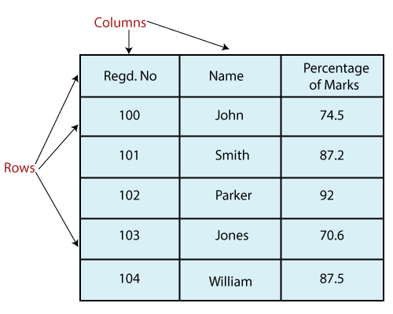

**Create a DataFrame:**

We can create a DataFrame using following ways:

* **dict**
* **Lists**
* **Numpy ndarrrays**
* **Series**

**Column Selection:**

We can select any column from the DataFrame.

**Column Addition:**

We can also add any new column to an existing DataFrame.

**Column Deletion:**

We can also delete any column from the existing DataFrame.

**Row Selection:**

We can select any row by passing the row label to a **loc** function. The rows can also be selected by passing the integer location to an **iloc** function. For selecting a row, we have passed the integer location to an **iloc** function. It is another method to select multiple rows using **':'** operator.

**Addition of rows:**

We can easily add new rows to the DataFrame using **append** function. It adds the new rows at the end.

**Deletion of rows:**

We can delete or drop any rows from a DataFrame using the **index** label. If in case, the label is duplicate then multiple rows will be deleted.

**DataFrame Functions**

There are lots of functions used in DataFrame which are as follows:

|  |  |
| --- | --- |
| **Functions** | **Description** |
| [Pandas DataFrame.append()](https://www.javatpoint.com/pandas-append) | Add the rows of other dataframe to the end of the given dataframe. |
| [Pandas DataFrame.apply()](https://www.javatpoint.com/pandas-apply) | Allows the user to pass a function and apply it to every single value of the Pandas series. |
| [Pandas DataFrame.assign()](https://www.javatpoint.com/pandas-dataframe-assign) | Add new column into a dataframe. |
| [Pandas DataFrame.astype()](https://www.javatpoint.com/pandas-dataframe-astype) | Cast the Pandas object to a specified dtype.astype() function. |
| [Pandas DataFrame.concat()](https://www.javatpoint.com/pandas-concatenation) | Perform concatenation operation along an axis in the DataFrame. |
| [Pandas DataFrame.count()](https://www.javatpoint.com/pandas-count) | Count the number of non-NA cells for each column or row. |
| [Pandas DataFrame.describe()](https://www.javatpoint.com/pandas-dataframe-describe) | Calculate some statistical data like percentile, mean and std of the numerical values of the Series or DataFrame. |
| [Pandas DataFrame.drop_duplicates()](https://www.javatpoint.com/pandas-dataframe-drop_duplicates) | Remove duplicate values from the DataFrame. |
| [Pandas DataFrame.groupby()](https://www.javatpoint.com/pandas-groupby) | Split the data into various groups. |
| [Pandas DataFrame.head()](https://www.javatpoint.com/pandas-dataframe-head) | Returns the first n rows for the object based on position. |
| [Pandas DataFrame.hist()](https://www.javatpoint.com/pandas-dataframe-hist) | Divide the values within a numerical variable into "bins". |
| [Pandas DataFrame.iterrows()](https://www.javatpoint.com/pandas-dataframe-iterrows) | Iterate over the rows as (index, series) pairs. |
| [Pandas DataFrame.mean()](https://www.javatpoint.com/pandas-dataframe-mean) | Return the mean of the values for the requested axis. |
| [Pandas DataFrame.melt()](https://www.javatpoint.com/pandas-melt) | Unpivots the DataFrame from a wide format to a long format. |
| [Pandas DataFrame.merge()](https://www.javatpoint.com/pandas-merge) | Merge the two datasets together into one. |
| [Pandas DataFrame.pivot_table()](https://www.javatpoint.com/pandas-pivot-table) | Aggregate data with calculations such as Sum, Count, Average, Max, and Min. |
| [Pandas DataFrame.query()](https://www.javatpoint.com/pandas-dataframe-query) | Filter the dataframe. |
| [Pandas DataFrame.sample()](https://www.javatpoint.com/pandas-dataframe-sample) | Select the rows and columns from the dataframe randomly. |
| [Pandas DataFrame.shift()](https://www.javatpoint.com/pandas-shift) | Shift column or subtract the column value with the previous row value from the dataframe. |
| [Pandas DataFrame.sort()](https://www.javatpoint.com/python-pandas-sorting) | Sort the dataframe. |
| [Pandas DataFrame.sum()](https://www.javatpoint.com/pandas-sum) | Return the sum of the values for the requested axis by the user. |
| [Pandas DataFrame.to_excel()](https://www.javatpoint.com/pandas-dataframe-to_excel) | Export the dataframe to the excel file. |
| [Pandas DataFrame.transpose()](https://www.javatpoint.com/pandas-dataframe-transpose) | Transpose the index and columns of the dataframe. |
| [Pandas DataFrame.where()](https://www.javatpoint.com/pandas-dataframe-where) | Check the dataframe for one or more conditions. |

* **OUTPUT:**

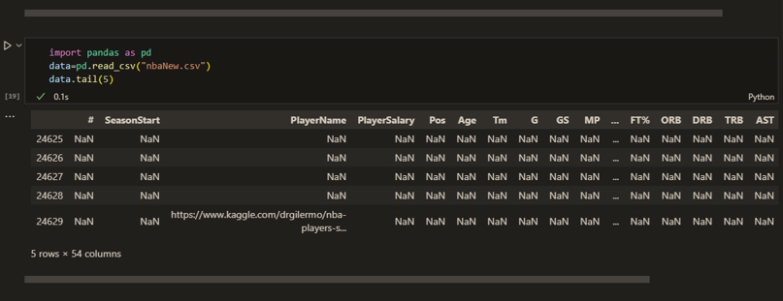

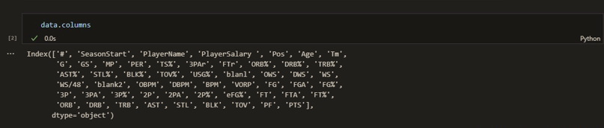

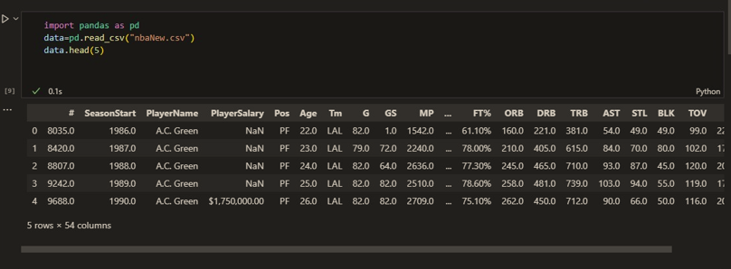

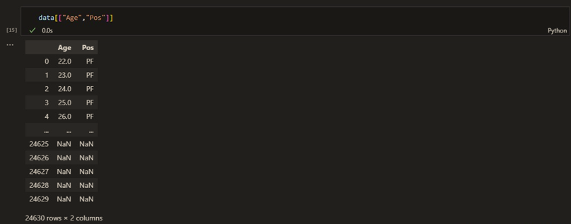

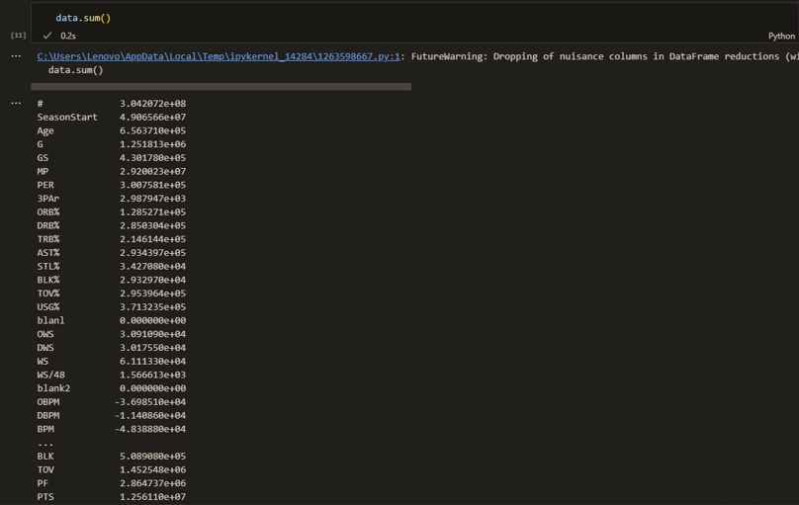

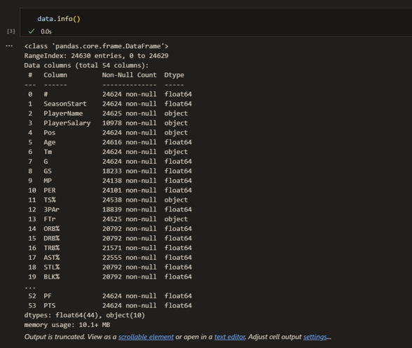

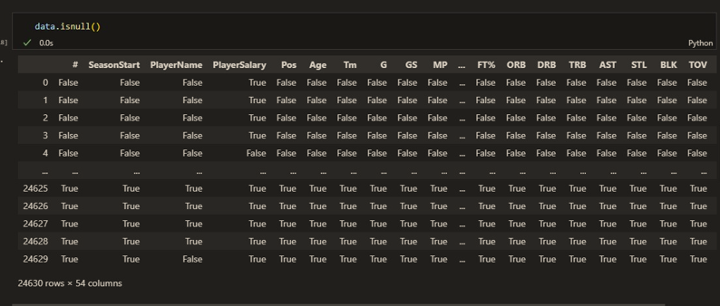

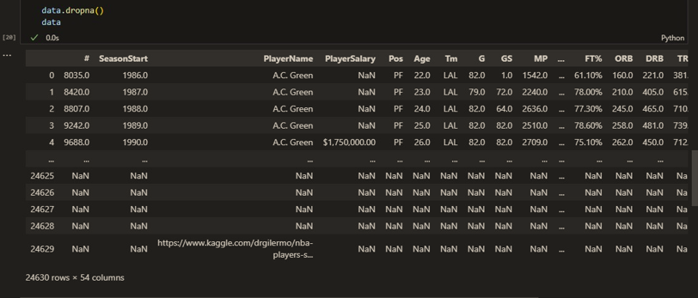

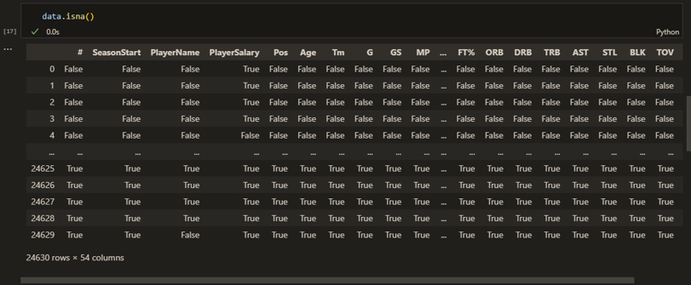

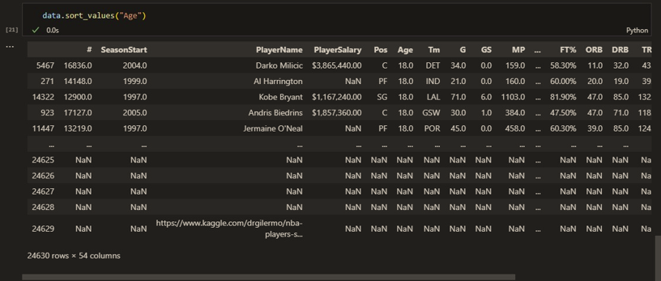

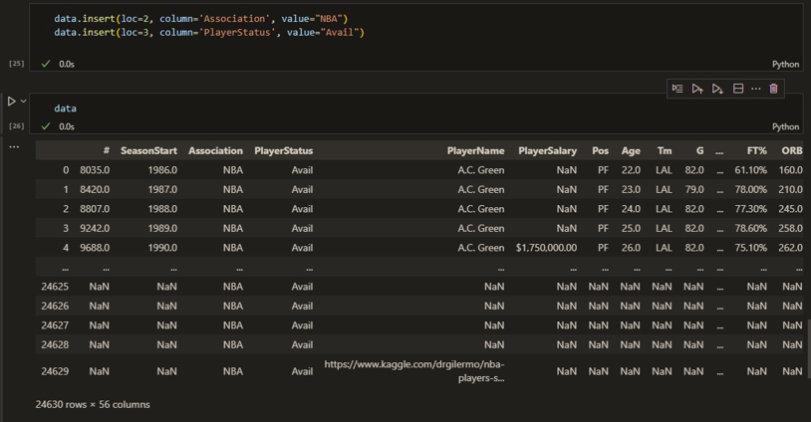

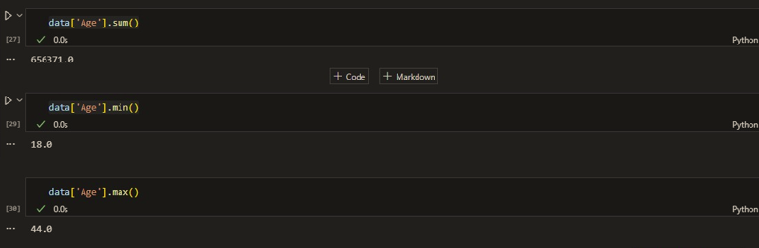

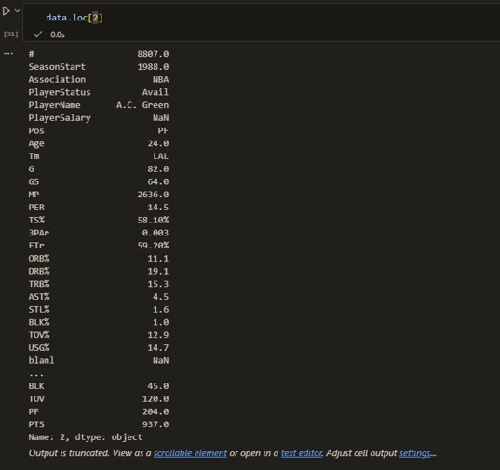

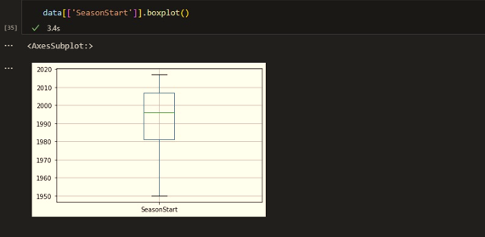

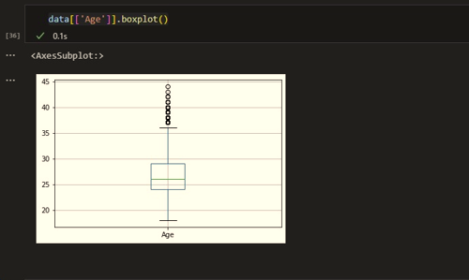

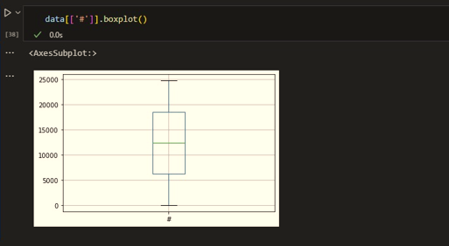

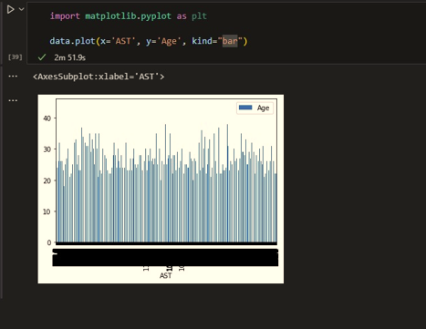

* ***CONCLUSION:*** **Hence, we have successfully implemented program on demonstrating Data Series and Data Frames using Pandas; LO 1.**